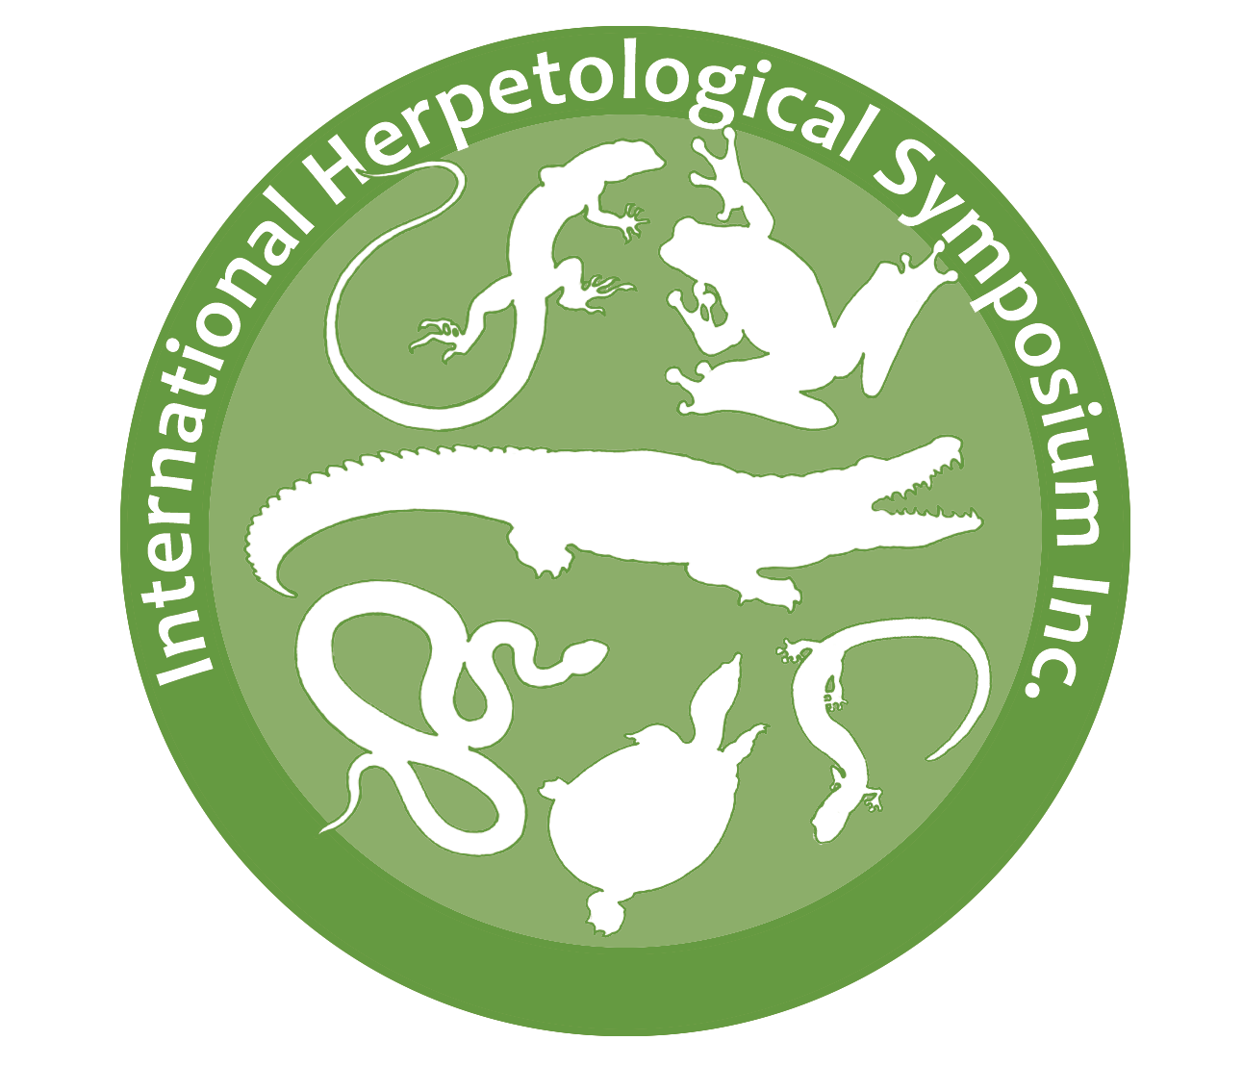

INTERNATIONAL HERPETOLOGIAL SYMPOSIUM
GRANT

The International Herpetological Symposium (IHS) Grant supports herpetological research, conservation, and education programs that seek to increase our basis of knowledge, protect, or raise awareness for reptile and amphibian species, both in natural and captive situations.
Grants will be selected for novel projects that represent a significant contribution to herpetoculture which expands or improves upon the areas of herpetological natural history, behavior, conservation biology, captive reproduction/husbandry, and/or education.
VALUE: Maximum annual request not to exceed US$1,000, although smaller value awards may be given to multiple projects annually. The total number of grants and amounts awarded will depend solely upon the balance of the dedicated grant fund in any given year.

SUBMISSION GUIDELINES
ELIGIBILITY: Applicants can be any individual from the herpetological community; applications will only be accepted from the PIs directly (i.e., no second-party, grant-matching organizations). Students are encouraged to apply. There are no eligibility restrictions on the nationality of the applicant.
Projects that have been funded by the IHS Grant are eligible for a second year of funding. A second application must be submitted according to the application guidelines, along with a progress report from the first year of IHS Grant funding.

DATES:
- April 30: As a SINGLE, DOWNLOADABLE document, ALL components of the application (narrative, CV, and letters of recommendations, attachments) must be dated and received before 11:59pm CDT on April 30 of the year for consideration. Any components that arrive after this or separately will not be accepted, and incomplete applications are not reviewed. Do NOT send protected Google Docs.
- September: Grant winners announced, and funds distributed before the end of the month.
- April 30, year following grant award received: Progress report due - must include an update on the status of the project and budgetary expenditures to date.
- Four months after project completed: Final report due – must include a summary of project objectives or methods used, conclusions, recommendations, and a statement of expenses.

ANY PROPOSALS THAT ARE NOT A SINGLE, DOWNLOADABLE FILE AND/OR DO NOT ADHERE TO THE GUIDELINES THAT FOLLOW WILL NOT BE CONSIDERED. All materials must be submitted in English and reviewers will be judging solely on the merits of each project. Unless otherwise specified, all of the following components must be included or will not be considered.
IHS GRANT APPLICATION
COVER SHEET (Single page with 10-point type minimum)
- Project title:
- Principal Investigator Name(s):
- Abstract (Project Summary - 250 words max):
- Amount requested (in US$):
- Total project budget (in US$):
- One contact person for grant application: (Must be a Principal Investigator)
- Address for communication:
  - Organization, if applicable:
  - Mailing address (include street, state, zip/postal code, and country):
  - Title:
  - Telephone:
  - E-mail:
- Proposed project period:
- Project location:
- Is this project new or part of an on-going project?
PROPOSAL NARRATIVE (Maximum of three pages with 10-point type minimum)
- INTRODUCTION TO THE PROJECT explaining in layman’s terms the rationale for the project, specific CATEGORY goals and objectives, and hypotheses to be tested. Clearly describe any applied conservation goals. Include sufficient information such that reviewers who may not be familiar with the subject matter will be able to understand and evaluate the project request. You must clearly state the goals and objectives of the project.
- METHODS/PLAN OF ACTION describing data collection methods, sample size, and detailed timetable including project's start and completion dates and dissemination plan. If appropriate, include an experimental design. Education-based projects should include a description of the evaluation component.
- DETAILED, ITEMIZED BUDGET for the project. Include a budget justification with a description of how the IHS grant money will be used. Be sure to clearly indicate the amount being requested specifically from the IHS Grant. If requesting partial funding, a complete project budget must be submitted. List amount and sources of in-kind support where applicable as well as support from other sources that have been obtained or is being sought. NOTE: Institutional overhead, salaries, and tuition will not be considered for funding, however reasonable stipends for field technicians may be considered.
PERMITS
Include copies of all permits necessary to perform the activities in the project. Include a copy of any institutional IACUC approval, if available.
CURRICULUM VITAE
All Principal Investigators must include Curriculum Vitae (two-page maximum each with a 10-point minimum).
LETTERS OF RECOMMENDATION
Two letters of recommendation for the project are necessary, including references’ contact email and phone number. If the applicant is a student, it is preferred to include a letter of support from his/her academic advisor and/or committee members.
LITERATURE CITED (Optional)
Literature cited in the proposal narrative may be listed on a separate page(s) with a 10-point minimum.
ATTACHMENTS (Optional)
Additional information may be included as attachment(s) but is not required. These may include photos, brochures, etc.
SEND completed application and support materials via electronic submission ONLY. EMAIL to intlherpsymp2@gmail.com. Required to have “IHS Grant Submission” in the subject line of email for consideration.
CONDITIONS OF ACCEPTANCE INCLUDE:
- Recipients will be required to present their findings at a future symposium, either in person or via poster at their own expense.
- Information gained from the project must be made available to the public.
- IHS, Inc. must receive a summary or final report by the dates indicated. Include a summary of project objectives or methods used, conclusions, recommendations, and a statement of expenses.
- IHS will be acknowledged as a sponsor in any printed materials produced as a result of the project (copy of the IHS logo can be made available upon request).
- All research must abide all local, state, and federal laws, and any research involving live animals must adhere to regulations listed under the USDA Animal Welfare Act.
- IHS grants do not pay for overhead of any kind.

